Sketch
Why float chassis between B+/-?
- Detectable high and low side chassis faults do not result in battery shorts
- Alternatives:
  - No battery-chassis ties
    - Still requires 2x battery-chassis faults to short battery (or direct battery rail to rail faults, but this is easier to avoid with layout and system design)
    - Chassis faults are not detectable
  - Tie chassis to Batt+
    - Phases will be driven to batt- periodically so any sensing on phase lines will have significant negative common-mode voltage
      - Current sense amps and other chips tend to have better high-side than low-side common mode ratings so this would influence how LV supplies will need to be ground referenced
    - Single chassis short from batt- shorts battery
  - Tie chassis to Batt-
    - Single chassis short from batt+ shorts battery

LV Loads
Current sense amp
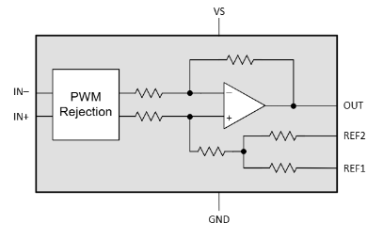
- If we use INA241 its 2.7 to 20 V
- Grounding constraints
  - 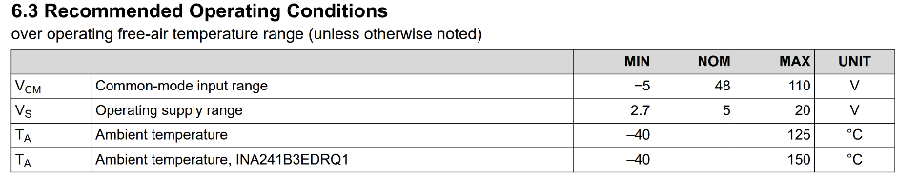
  - Common mode rating limits us on low side. The power supply for the amp should not go far above Batt-

Differential amp (phase voltage, batt voltage, chassis voltage)
- Probably similar to the current sense amp

Gate driver
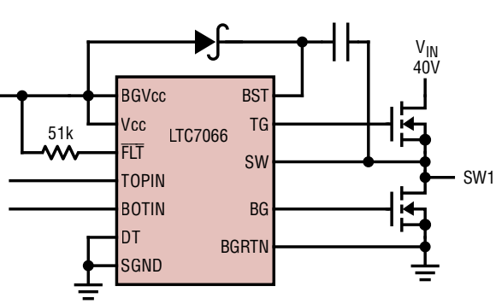
- 5 to 14V for LTC7066
- Grounding constraints (SGND is chip power supply gnd):
  - 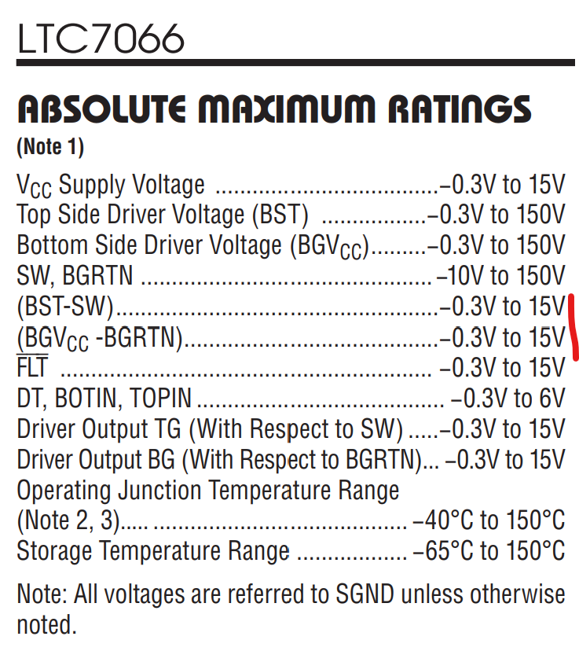
    - The BST-SW (or BGV_cc - BGRTN) ratings dictate the allowable DC offset between Batt- and SGND. If Vcc = 12V then SGND can be no more than 3V higher than Batt-, else the bootstrap cap will drive BST 15V above Batt-
      - The recommended ratings pose tighter bounds here
      - 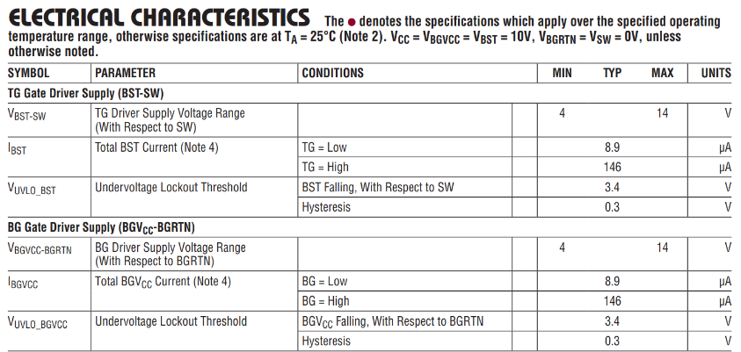
    - The BOTIN and TOPIN limits may also be a concern. They limit the 12V and 5/3V3 ground ref offsets. May need an optoisolator on the PWM command lines if I want these power rails to have different ground refs

ADC
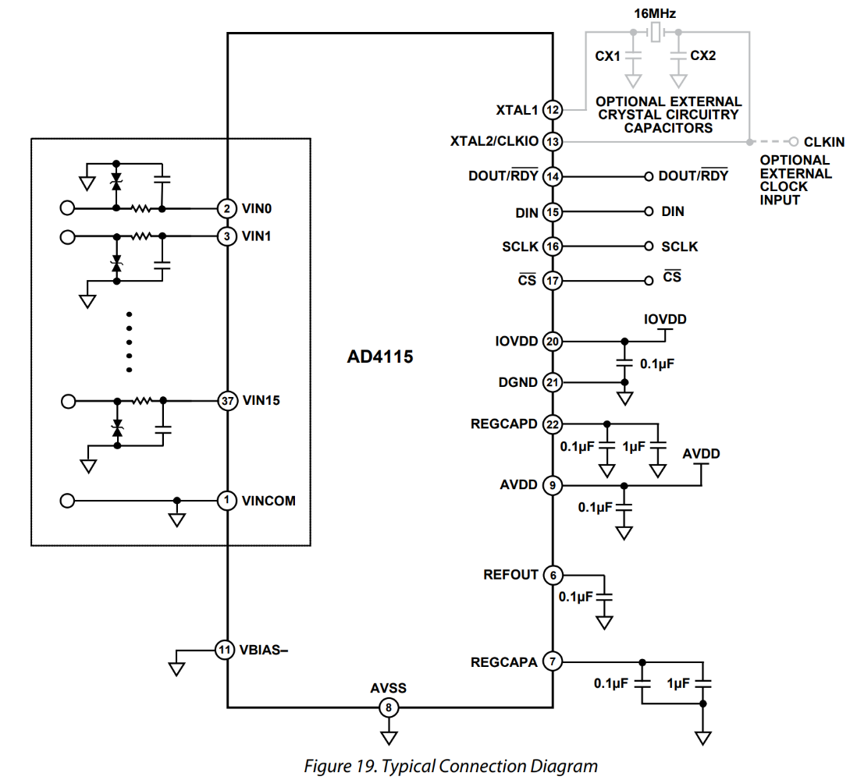
- AVDD = 4.5 V to 5.5 V
- IOVDD = 2 V to 5.5 V

From <https://www.analog.com/en/products/AD4115.html>
- Can do NRSE (provide ref voltage for single ended inputs that is not AGND
- Grounding constraints
  - 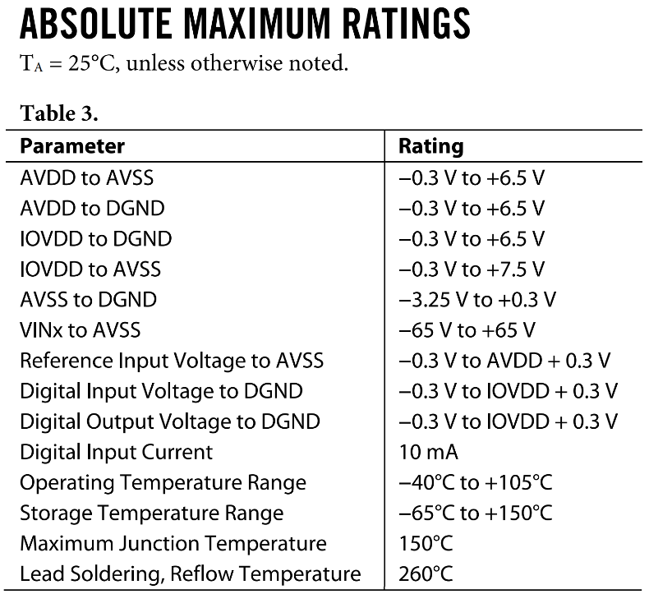
    - These are pretty generous. "Reference Input Voltage" is for external Vref, but theres a built-in 2.5V internal ref that we are probably good to use
    - I think the only one of note here is the Vinx to Avss which will dictate the allowable VINCOM to analog power offset. If we want the current sense/differential amps to use the 12V supply, this still allows DC offsets between the 12V and 5/3V3 ground refs that are larger than Vbatt… so that’s cool
ESP32 and its other peripherals (IMU/MPU, UART transceiver, etc)
- mostly 5V and 3V3 probably

Ground reference bonding options
There are 3 different “ground” references that I need to consider here:
- Chassis ground
  - Floated at Vbatt/2 or similar
- 12V gnd
  - Definitely used for gate driver chip power (no margin if using 5V for LTC7066)
- 5V gnd
  - Definitely used for ADC (driven by AD4115 ratings)
  - Assuming this is also 3V3 gnd because ESP32 dev board uses LDO for 3V3 rail
We could use either 5V or 12V for the current sense amp circuit (and probably also the voltage sense amp circuit)
Here is a summary of relevant restrictions from selected chip ratings
- 12V gnd – Batt- <= 2V
  - Derived from: Gate driver BST-SW voltage rating
  - We get 1V of margin back for every 1V we reduce the 12V rail (ex. if the rail is 8V instead of 12V, then this restriction is instead 12V gnd – Batt- <= 6V)
- Need optoisolators on gate drive commands if 12V gnd != 5V gnd
  - Derived from: gate driver design (shared ground reference for chip power and digital inputs)
  - We may be able to get away with small differences here but it would require some testing I think. Probably not really worth it
- Current sense amp power ground – Batt- >= -5
  - Derived from: amp common mode rating along with phase-sensing architecture
  - Could eliminate this requirement with low-side current sensing
  - Ignoring voltage across shunt resistor (taking worst case common mode)
#1 points to using Batt- as a ground reference for 12V
#2 lightly points to using 12V gnd = 5V gnd. Reduces component count
#3 is satisfied by Batt- = 12V gnd if current sense amp is powered by 12V rail
#3 is satisfied by Batt- = 12V gnd if 12V gnd = 5V gnd (ie. taking the suggestions from #1 and #2 automatically satisfies #3 for either allowable current sense amp power supply)

So we are seemingly leaning towards a configuration where Batt- is used as the ground reference for all our LV power (12V, 5V, 3V3). Possible drawbacks of this config
- Battery drives motor currents. High/switching currents will pass through batt- conductors
  - Need to be careful about where we reference LV grounds within batt- conductor structure
- Will result in more batt- conductor volume within PCB, which increases likelihood of shorts to batt-
  - This feels like a pretty minor one to me especially if we stick with a detectable 1FT battery-chassis short design

